Article Attribute

✅ What is Article Attribute?
# Source: AI Source: Provided by: [Data Path: Persons Table -> ID Column: 1, Name_En Column: Motasem Essam] -> From: [Chatgpt (GPT‑5 Mini)] on [8/7/2025]
An Article Attribute is an article (a, an, the) that functions as a modifier placed before a noun to determine definiteness (specific vs. general). It is a type of limiting attribute, helping to clarify which noun or how many are being referred to.

🔹 Types of Articles:
# Source: AI Source: Provided by: [Data Path: Persons Table -> ID Column: 1, Name_En Column: Motasem Essam] -> From: [Chatgpt (GPT‑5 Mini)] on [8/7/2025]
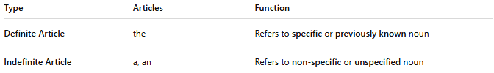
Type | Articles | Function
Definite Article | the | Refers to specific or previously known noun
Indefinite Article | a, an | Refers to non-specific or unspecified noun

🔹 Key Features:
# Source: AI Source: Provided by: [Data Path: Persons Table -> ID Column: 1, Name_En Column: Motasem Essam] -> From: [Chatgpt (GPT‑5 Mini)] on [8/7/2025]
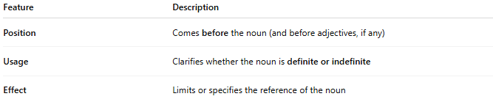
Feature | Description
Position | Comes before the noun (and before adjectives, if any)
Usage | Clarifies whether the noun is definite or indefinite
Effect | Limits or specifies the reference of the noun

🔹 Examples in Sentences:
# Source: AI Source: Provided by: [Data Path: Persons Table -> ID Column: 1, Name_En Column: Motasem Essam] -> From: [Chatgpt (GPT‑5 Mini)] on [8/7/2025]
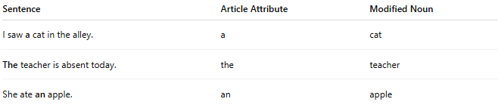
Sentence | Article Attribute | Modified Noun
I saw a cat in the alley. | a | cat
The teacher is absent today. | the | teacher
She ate an apple. | an | apple

🔹 Comparison with Other Attribute Types:
# Source: AI Source: Provided by: [Data Path: Persons Table -> ID Column: 1, Name_En Column: Motasem Essam] -> From: [Chatgpt (GPT‑5 Mini)] on [8/7/2025]
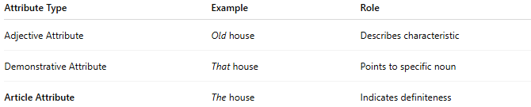
Attribute Type | Example | Role
Adjective Attribute | Old house | Describes characteristic
Demonstrative Attribute | That house | Points to specific noun
Article Attribute | The house | Indicates definiteness

